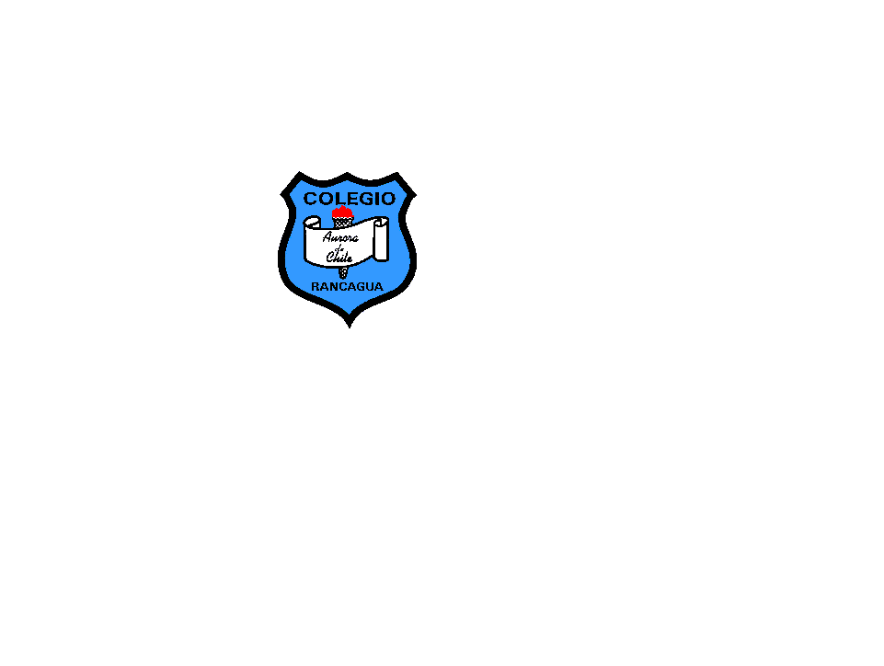

COLEGIO AURORA DE CHILE

CORMUN RANCAGUA 2020

English 3° grade worksheet N°2

Name _________________________________ Date: March18th

|  |  |  |  |  |  |
| --- | --- | --- | --- | --- | --- |
| 1. Number the pictures below. | | | | | |
| (1) books | (2) crayons | (3) eraser | (4) rulers | (5) pen | (6) pencils |
|  | | | | | |

II- Read and draw (lee y dibuja)

|  |  |  |  |
| --- | --- | --- | --- |
|  |  |  |  |
| Rubber | Pen | Sharpener | schoolbag |

|  |  |  |  |
| --- | --- | --- | --- |
|  |  |  |  |
| Pencil case | Book | Ruler | pencil |